The device uses a PIR motion sensor to detect the human motion and this information is transmitted without wire by using a RF transmitter-receiver module to give some sort of alert. We choose a RF module for wireless communication because compared to the existing wireless systems like blue tooth,XBee or WiFi ,it is user friendly and very cheap.

We used IR, but that has a limited range and can only work within a line of sight of the receiver. But using the cheap RF module we can communicate within the range of around 100m.

We divided the entire project in to 3 major parts;

**1.TRANSMITTER :** To sense the human motion and transmit the data to receiver

**2. RECEIVER :**Receive the data from transmitter and activate alarm system and camera or sending a sms etc

**3.SOFTWARE :** That operates the entire hardware used in this project.

**Step 1: PARTS AND TOOLS REQUIRED**

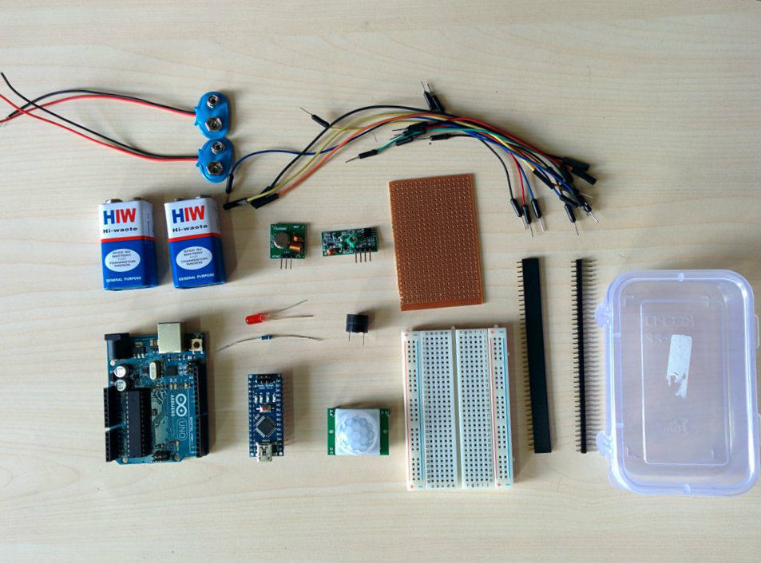

1. ARDUINO UNO/ARDUINO MINI/ARDUINO NANO or similar board (Tx)

2. ARDUINO UNO /ARDUINO MINI/ARDUINO NANO or similar board (Rx)

3. RF Transmitter and Receiver Module (433 MHZ)

4. PIR sensor

4. 9V battery ( 2 nos) and connectors

5. Buzzer

6. LED

7. Resistor -220 ohm

8. Bread Board

9. Jumper Wires

10. perforated Board

11. Header connectors

12.Switches

13. Project Enclosure

14. Black Paper

15. Scotch Mounting Pad

**TOOLS REQUIRED :**

1.Hobby Knife

2.Glue Gun

3.Soldering Iron

4.Wire cutter /Stripper

5.Tin Snips

**Step 2: TRANSMITTER**

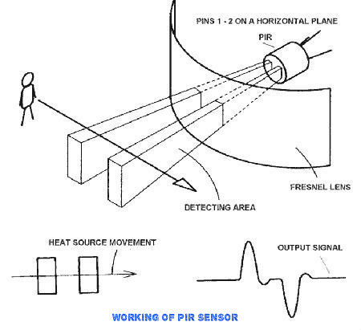

1. PIR sensor to detect the human motion

2.Arduino to process the data from PIR sensor

3. RF transmitter to transmit the data to the receiver

Passive infrared sensors work by measuring incoming infrared from human or animal. They do not emit energy themselves, which is why they are called "passive". Humans and animals both release infrared energy. Passive infrared sensors(sometimes called pyro electric detectors) detect this energy and give a signal to the ARDUINO.

For transmitter I used a Arduino Nano board to reduced the cost. Of course your Arduino Uno also works fine.You can also use a Arduino mini Pro which cheaper than nano.As now I do not have a FTDI module to program the mini board I choose the nano board.

**Connect the PIR sensor**

PIR Pin Arduino Pin

vcc -----> 5v

GND . ......> GND

Out ........> D2

Before uploading the code set the correct board and serial port in the Arduino IDE. Then upload the sketch given bellow.

When there is motion in front of the sensor the LED will glow.

**Step 3: Connect The RF Transmitter**

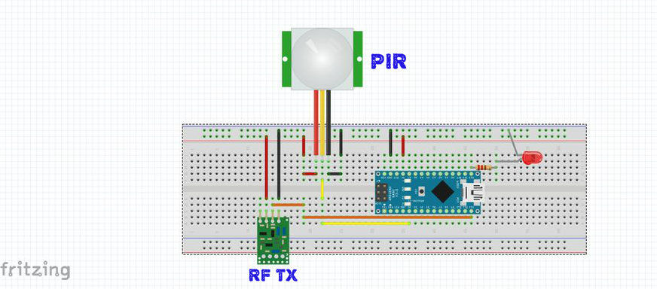

In the previous step we confirmed that your PIR sensor is working fine.Now we added the RF transmitter to the board.

The RF transmitter has 3 pins( VCC, GND, and Data).

Connect the VCC pin to the 5V pin of the Arduino board that we are using (In my case it is Nano).

Connect the GND to the GND of the Arduino board.

Connect the data pin to the pin number 12 of the Arduino board.

**Step 4: RECEIVER**

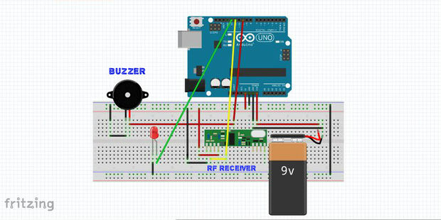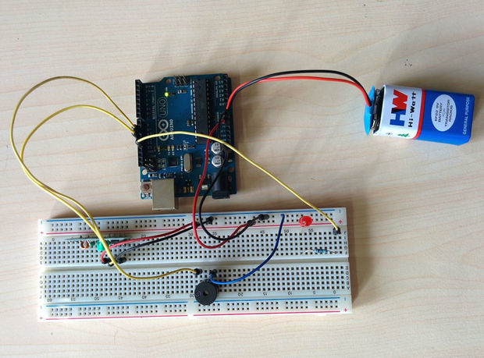

The **Receiver** consists of

1. RF Receiver module to receive data from transmitter

2. Arduino to process the data from RF Tx and give an out put (alarm,sms,email etc)

3. Out Put : buzzer

Connect the VCC pin to the 5V pin of the Arduino board that you are using (In my case it is Uno).

Connect the GND to the GND of the Arduino board.

Connect the data pin to the pin number 12 of the Arduino board.

**Step 5: SOFTWARE**

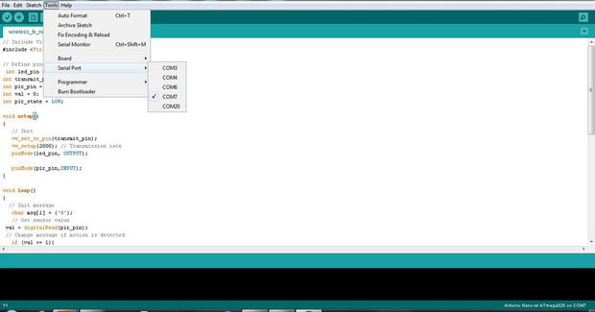

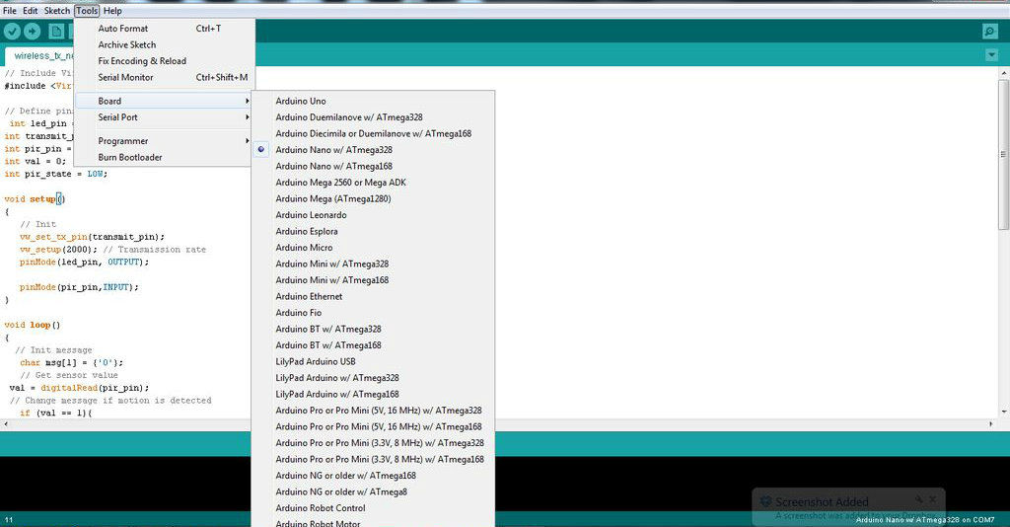

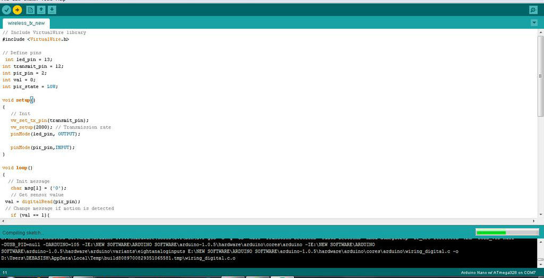

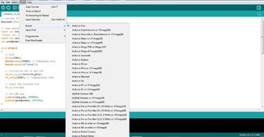

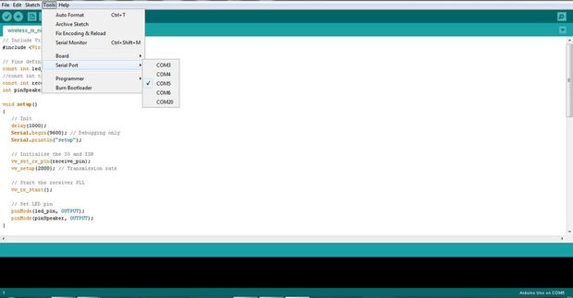

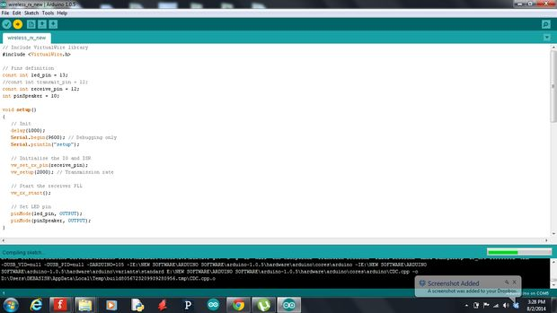

**Virtual Wire Library is needed for this. It has been made available.**

**Software for Transmitter:**

1.Board -> Arduino Nano (what board you have used)

2.Serial Port -> COM XX (check the com port in which your device is connected )

**Software for Receiver:**

Similar to the above we settled up the following for receiver board

1.Board -> Arduino UNO (what board you have used)

2.Serial Port -> COM XX (check the com port in which your device is connected)

**Step 6: BREAD BOARD TEST**

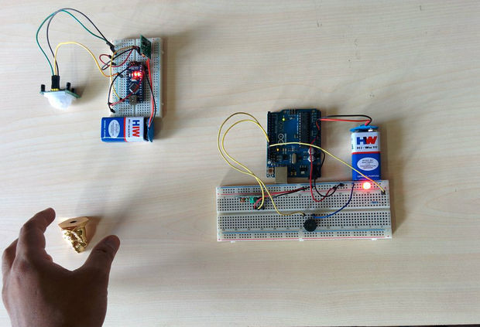

Remove the Usb cable from both the board

Provide external power (battery ) to the both the board.( positive terminal goes to Vin )

Then shake hand in front of the PIR sensor.

If the buzzer in the receiver board starts to make noise then every thing works fine.

**Step 7: MAKE THE TRANSMITTER MODULE**

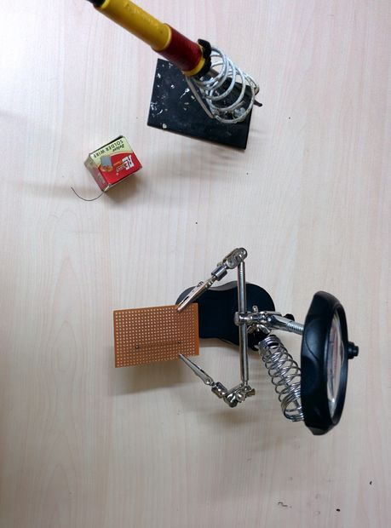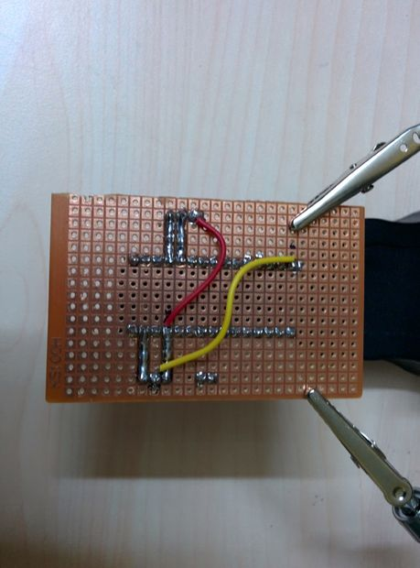

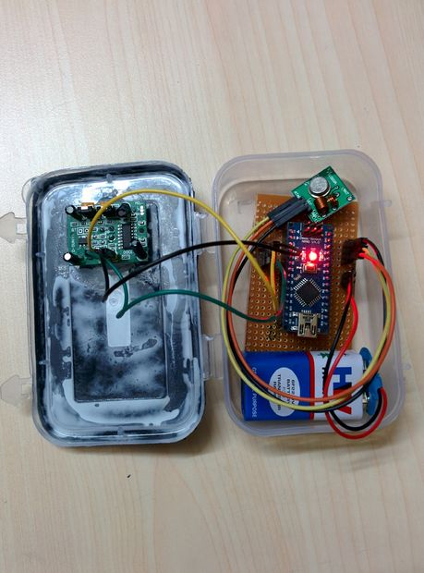

Cut header connectors for arduino nano (15 pins 2nos ),PIR sensor (3 pins),RF transmitter (3 pins) and Power (2 pins).

Solder the header according to the schematic.

Place the arduino nano board over the header and connect jumper wires to PIR sensor and RF transmitter.

**Prepare the Enclosure**

Make a circular hole in the enclosure to insert the PIR sensor.

Glue it to the surrounding in such a way that it will fix perfectly.

Make a rectangular hole to insert the power switch and glue it.

Wrap a color paper (black) on the front surface of the enclosure.I made this to hide everything inside the enclosure.

It also gives a better look to the device.

**Place everything inside**

Switch on the switch to check the power.

**Step 8: MAKE THE RECEIVER MODULE**

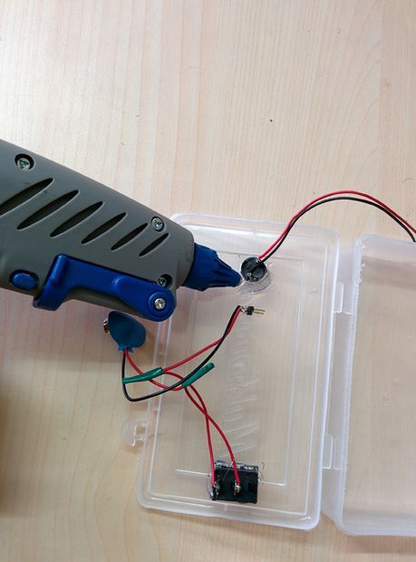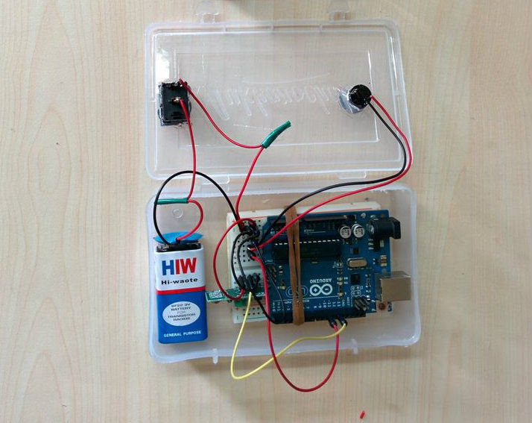

Place the RF receiver module on the bread board

Connect everything by jumper wires as per schematics

**Prepare the Enclosure :**

Mark a circle and rectangle on the front side of the enclosure.

Cut the marked portion.

Insert buzzer in the circular hole and switch in the rectangular hole.Then glue them.

Place every thing inside.

After making the both modules,place the transmitter module to the location where you want to protect. The receiver module should be placed inside the room.

**Step 9: How to Increase The Range**

**How to Calculate Antenna Length :**

The way to calculate the antenna length is to divide the speed of light by the frequency to calculate the wavelength, and divide that by 4 to get a quarter length.

the frequency we got was 433Mhz

Speed of the light is 3x10^8 m/s

Wavelength = Speed of light (c) / Frequency (f)

= ( 3x10^8) / (433x10^6)

= 0.69284 m

Antenna length = Wavelength /4

=0.69284/4 = 0.1732 m =17.32 cm or 6.82 inch

From the above calculation it comes out to about 17.3 cm or 6.8 inches. Just cut a piece of wire 6.8 inches long and solder it into that hole marked with**ANT**, on each module. putting the wires on there makes a great difference.

**Step 10: POWER SUPPLY AND OPTIMIZATION**

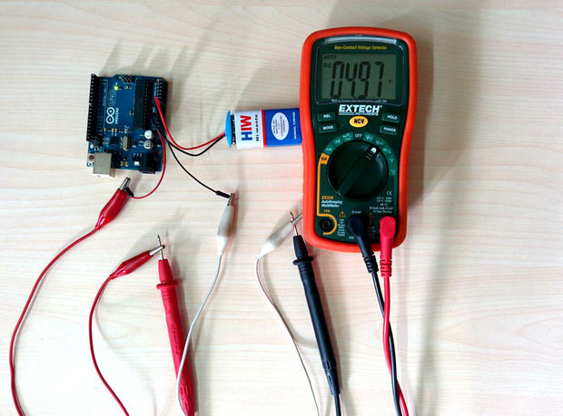

During the uploading of codes, the board is powered by USB cable but when ever you want to use it in the real world,you need an external power supply.it is usually impractical to run long power cables out to the sensor’s location. So for external power supply battery is the best option. There are several types of battery exist in the market. So choose according to your choice.In this project we used 9V battery.A high capacity battery pack can be used for longer life.

Connecting a 9V battery directly to the arduino board is some what tricky. Connect the positive terminal of the battery to the Vin pin of the arduino and negative terminal of the battery to the GND pin of the arduino. After connecting the battery,we measured the voltage across 5v and GND pin it is 4.97v which is safe for our operation.

The main power consuming element in the board is led for power indication and the voltage regulator.

**Power Optimization**

Your module will run when the voltage level is sufficient. When the voltage in the pack drops below a certain threshold, the sensor system shuts down, even though there is still some remaining “juice” in the battery cells.

This little juice can be successfully extracted by using a boost converter.

**Step 11: Ideas to take the projects to a higher level**

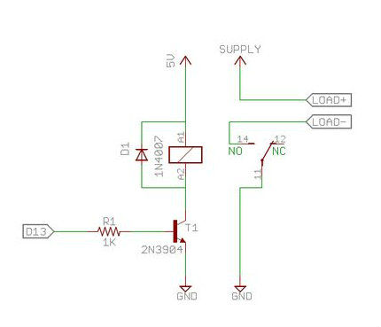

Though in this project we have just shown you to make some sound for alert but you can do lot of things by modifying few things in hardware and software.

Use a relay instead of buzzer which can be used to

1. DOOR OPEN / CLOSE

2. APPLIANCES ON/OFF

Use a camera to take pictures when there is a motion and send it to your email. This can be used to monitor your sleeping baby.

We can send sms to your mobile when there is a motion..